What is Django?, Django is a Python framework that makes it easier to create web sites using Python. Django takes care of the difficult stuff so that you can concentrate on building your web applications. Django emphasizes reusability of components, also referred to as DRY (Don't Repeat Yourself), and comes with ready-to-use features like login system, database connection and CRUD operations (Create Read Update Delete).
Django is especially helpful for database driven websites.
Django follows the MVT design pattern (Model View Template).
- Model - The data you want to present, usually data from a database.
- View - A request handler that returns the relevant template and content - based on the request from the user.
- Template - A text file (like an HTML file) containing the layout of the web page, with logic on how to display the data.

Model. The model provides data from the database. In Django, the data is delivered as an Object Relational Mapping (ORM), which is a technique designed to make it easier to work with databases.
The most common way to extract data from a database is SQL. One problem with SQL is that you have to have a pretty good understanding of the database structure to be able to work with it.
Django, with ORM, makes it easier to communicate with the database, without having to write complex SQL statements. The models are usually located in a file called models.py.

View. Is a function or method that takes http requests as arguments, imports the relevant model(s), and finds out what data to send to the template, and returns the final result. The views are usually located in a file called views.py.

Template. Is a file where you describe how the result should be represented. Templates are often .html files, with HTML code describing the layout of a web page, but it can also be in other file formats to present other results, but we will concentrate on .html files. Django uses standard HTML to describe the layout, but uses Django tags to add logic:
<h1>My Homepage</h1>
<p>My name is {{ firstname }}.</p>
The templates of an application is located in a folder named templates.

URLs. Django also provides a way to navigate around the different pages in a website. When a user requests a URL, Django decides which view it will send it to. This is done in a file called urls.py.

So, What is Going On?. When you have installed Django and created your first Django web application, and the browser requests the URL, this is basically what happens:
- Django receives the URL, checks the urls.py file, and calls the view that matches the URL.
- The view, located in views.py, checks for relevant models.
- The models are imported from the models.py file.
- The view then sends the data to a specified template in the template folder.
- The template contains HTML and Django tags, and with the data it returns finished HTML content back to the browser.
Django can do a lot more than this, but this is basically what you will learn in this tutorial, and are the basic steps in a simple web application made with Django.

Django requires Python. To check if your system has Python installed, run this command in the command prompt:
python --version
If Python is installed, you will get a result with the version number, like this Python 3.11.1
pip –version # ->
pip 22.3.1 from C:\Users\GERMANCB\AppData\Roaming\Python\Python311\site-packages\pip (python 3.11)
If PIP is installed, you will get a result with the version number. For me, on a windows machine, the result looks like this: pip 22.2.1 from c:…..

Virtual Environment. It is suggested to have a dedicated virtual environment for each Django project, and one way to manage a virtual environment is venv, which is included in Python. The name of the virtual environment is your choice, in this tutorial we will call it myworld. Type the following in the command prompt, remember to navigate to where you want to create your project:
Windows:
py -m venv myworld
Unix/MacOS: python -m venv myworld
This will set up a virtual environment, and create a folder named "myworld" with subfolders and files, like this:
myworld
Include
Lib
Scripts
pyvenv.cfg

Then you have to activate the environment, by typing this command: Windows:
myworld\Scripts\activate.bat
Unix/MacOS: source myworld/bin/activate
Once the environment is activated, you will see this result in the command prompt: Windows:
(myworld) C:\Users\Your Name>
Unix/MacOS: (myworld) ... $
Note: You must activate the virtual environment every time you open the command prompt to work on your project.

Install Django. Now, that we have created a virtual environment, we are ready to install Django.
Note: Remember to install Django while you are in the virtual environment!
Django is installed using pip, with this command: Windows:
(myworld) C:\Users\Your Name>py -m pip install Django
Unix/MacOS: (myworld) ... $ python -m pip install Django
Which will give a result that looks like this (at least on my Windows machine):
Collecting Django
Downloading Django-4.0.3-py3-none-any.whl (8.0 MB)
|████████████████████████████████| 8.0 MB 2.2 MB/s
Collecting sqlparse>=0.2.2
Using cached sqlparse-0.4.2-py3-none-any.whl (42 kB)
Collecting asgiref<4,>=3.4.1
Downloading asgiref-3.5.0-py3-none-any.whl (22 kB)
Collecting tzdata; sys_platform == "win32"
Downloading tzdata-2021.5-py2.py3-none-any.whl (339 kB)
|████████████████████████████████| 339 kB 6.4 MB/s
Installing collected packages: sqlparse, asgiref, tzdata, Django
Successfully installed Django-4.0.3 asgiref-3.5.0 sqlparse-0.4.2 tzdata-2021.5
WARNING: You are using pip version 20.2.3; however, version 22.3 is available.
You should consider upgrading via the 'C:\Users\Your Name\myworld\Scripts\python.exe -m pip install --upgrade pip' command.

Windows: py –-version ->Python 3.11.1

Check Django Version. You can check if Django is installed by asking for its version number like this:
(myworld) C:\Users\Your Name>django-admin –version -> 4.1.5
If Django is installed, you will get a result with the version number: 4.1.2

My First Project. Once you have come up with a suitable name for your Django project, like mine: my_tennis_club, navigate to where in the file system you want to store the code (in the virtual environment), I will navigate to the myworld folder, and run this command in the command prompt:
django-admin startproject my_tennis_club
Django creates a my_tennis_club folder on my computer, with this content:
my_tennis_club
manage.py
my_tennis_club/
__init__.py
asgi.py
settings.py
urls.py
wsgi.py
These are all files and folders with a specific meaning, you will learn about some of them later in this tutorial, but for now, it is more important to know that this is the location of your project, and that you can start building applications in it.

Run the Django Project. Now that you have a Django project, you can run it, and see what it looks like in a browser. Navigate to the /my_tennis_club folder and execute this command in the command prompt:
(myworld) C:\Users\GERMANCB\my_tennis_club>py manage.py runserver
Which will produce this result:
Watching for file changes with StatReloader
Performing system checks...
System check identified no issues (0 silenced).
January 16, 2023 - 08:56:44
Django version 4.1.5, using
[16/Jan/2023 08:56:56] "GET /favicon.ico HTTP/1.1" 404 179
[16/Jan/2023 08:56:59] "GET /members/ HTTP/1.1" 200 567
[16/Jan/2023 08:57:03] "GET / HTTP/1.1" 200 210
using settings 'my_tennis_club.settings'
Starting development server at http://127.0.0.1:8000/
Quit the server with CTRL-BREAK.
Ejecución en Acer. C:\Users\GERMANCB>pip --version
pip 22.3.1 from C:\Users\GERMANCB\AppData\Roaming\Python\Python311\site-packages\pip (python 3.11)
C:\Users\GERMANCB>py -m venv myworld
C:\Users\GERMANCB>myworld\Scripts\activate.bat
(myworld) C:\Users\GERMANCB>py -m pip install Django
Collecting Django
Downloading Django-4.1.5-py3-none-any.whl (8.1 MB)
---------------------------------------- 8.1/8.1 MB 8.6 MB/s eta 0:00:00
Collecting asgiref<4,>=3.5.2
Downloading asgiref-3.6.0-py3-none-any.whl (23 kB)
Collecting sqlparse>=0.2.2
Downloading sqlparse-0.4.3-py3-none-any.whl (42 kB)
---------------------------------------- 42.8/42.8 kB 417.0 kB/s eta 0:00:00
Collecting tzdata
Downloading tzdata-2022.7-py2.py3-none-any.whl (340 kB)
---------------------------------------- 340.1/340.1 kB 5.3 MB/s eta 0:00:00
Installing collected packages: tzdata, sqlparse, asgiref, Django
C:Users/GERMANCB
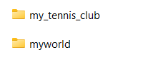
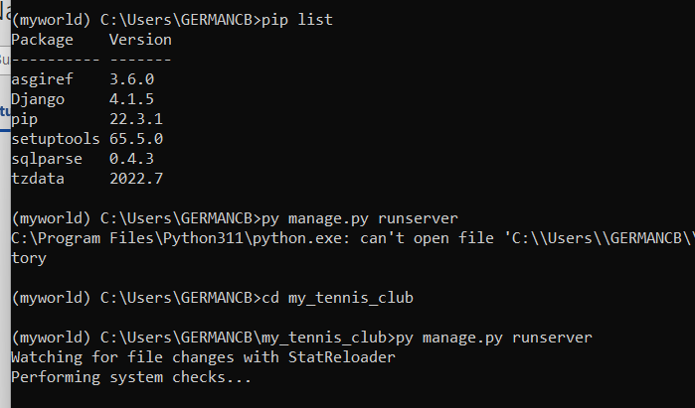
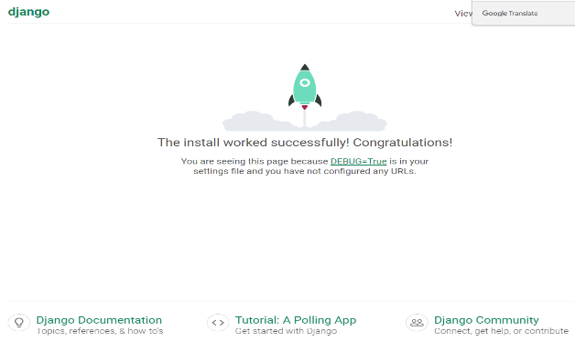

DJANGO. Create an APP
An app is a web application that has a specific meaning in your project, like a home page, a contact form, or a members database. In this tutorial we will create an app that allows us to list and register members in a database. But first, let's just create a simple Django app that displays "Hello World!".
I will name my app members.
Start by navigating to the selected location where you want to store the app, in my case the my_tennis_club folder, and run the command below.
If the server is still running, and you are not able to write commands, press [CTRL] [BREAK], or [CTRL] [C] to stop the server and you should be back in the virtual environment.
py manage.py startapp members
Django creates a folder named members in my project, with this content:
my_tennis_club
manage.py
my_tennis_club/
members/
migrations/
__init__.py
__init__.py
admin.py
apps.py
models.py
tests.py
views.py
These are all files and folders with a specific meaning. You will learn about most of them later in this tutorial.
First, take a look at the file called views.py.

DJANGO VIEWS. Django views are Python functions that takes http requests and returns http response, like HTML documents. A web page that uses Django is full of views with different tasks and missions. Views are usually put in a file called views.py located on your app's folder.
There is a views.py in your members folder that looks like this:
my_tennis_club/members/views.py:
from django.shortcuts import render
# Create your views here.
Find it and open it, and replace the content with this:
my_tennis_club/members/views.py:
from django.shortcuts import render
from django.http import HttpResponse
def members(request):
return HttpResponse("Hello world!")
Note: The name of the view does not have to be the same as the application. I call it members because I think it fits well in this context. This is a simple example on how to send a response back to the browser. But how can we execute the view? Well, we must call the view via a URL. You will learn about URLs in the next chapter.

DJANGO URLs. Create a file named urls.py in the same folder as the views.py file, and type this code in it:
my_tennis_club/members/urls.py:
from django.urls import path
from . import views
urlpatterns = [
path('members/', views.members, name='members'),
]
The urls.py file you just created is specific for the members application. We have to do some routing in the root directory my_tennis_club as well. This may seem complicated, but for now, just follow the instructions below.
There is a file called urls.py on the my_tennis_club folder, open that file and add the include module in the import statement, and also add a path() function in the urlpatterns[] list, with arguments that will route users that comes in via 127.0.0.1:8000/.
Then your file will look like this:
my_tennis_club/my_tennis_club/urls.py:
from django.contrib import admin
from django.urls import include, path
urlpatterns = [
path('', include('members.urls')),
path('admin/', admin.site.urls),
]
If the server is not running, navigate to the /my_tennis_club folder and execute this command in the command prompt:
py manage.py runserver
In the browser window, type 127.0.0.1:8000/members/ in the address bar.
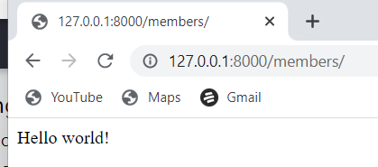
Django Templates. In the Django Intro page, we learned that the result should be in HTML, and it should be created in a template, so let's do that.
Create a templates folder inside the members folder, and create a HTML file named myfirst.html.
The file structure should be like this:
my_tennis_club
manage.py
my_tennis_club/
members/
templates/
myfirst.html
Open the HTML file and insert the following:
my_tennis_club/members/templates/myfirst.html:
<!DOCTYPE html>
<html>
<body>
<h1>Hello World!</h1>
<p>Welcome to my first Django project!</p>
</body>
</html>

Modify the View. Open the views.py file and replace the members view with this:
my_tennis_club/members/views.py:
from django.http import HttpResponse
from django.template import loader
def members(request):
template = loader.get_template('myfirst.html')
return HttpResponse(template.render())

Change Settings. To be able to work with more complicated stuff than "Hello World!", We have to tell Django that a new app is created. This is done in the settings.py file in the my_tennis_club folder.
Look up the INSTALLED_APPS[] list and add the members app like this:
my_tennis_club/my_tennis_club/settings.py:
INSTALLED_APPS = [
'django.contrib.admin',
'django.contrib.auth',
'django.contrib.contenttypes',
'django.contrib.sessions',
'django.contrib.messages',
'django.contrib.staticfiles',
'members'
]

Then run this command:
py manage.py migrate
Which will produce this output:
Operations to perform:
Apply all migrations: admin, auth, contenttypes, sessions
Running migrations:
Applying contenttypes.0001_initial... OK
Applying auth.0001_initial... OK
Applying admin.0001_initial... OK
Applying admin.0002_logentry_remove_auto_add... OK
Applying admin.0003_logentry_add_action_flag_choices... OK
Applying contenttypes.0002_remove_content_type_name... OK
Applying auth.0002_alter_permission_name_max_length... OK
Applying auth.0003_alter_user_email_max_length... OK
Applying auth.0004_alter_user_username_opts... OK
Applying auth.0005_alter_user_last_login_null... OK
Applying auth.0006_require_contenttypes_0002... OK
Applying auth.0007_alter_validators_add_error_messages... OK
Applying auth.0008_alter_user_username_max_length... OK
Applying auth.0009_alter_user_last_name_max_length... OK
Applying auth.0010_alter_group_name_max_length... OK
Applying auth.0011_update_proxy_permissions... OK
Applying auth.0012_alter_user_first_name_max_length... OK
Applying sessions.0001_initial... OK
(myworld) C:\Users\Your Name\myworld\my_tennis_club>
Start the server by navigating to the /my_tennis_club folder and execute this command:
py manage.py runserver
In the browser window, type 127.0.0.1:8000/members/ in the address bar.
The result should look like this:
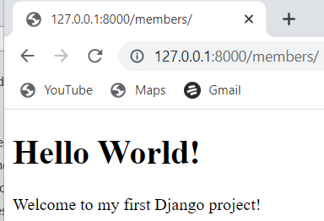

Django Models. Up until now in this tutorial, output has been static data from Python or HTML templates. Now we will see how Django allows us to work with data, without having to change or upload files in the prosess.
In Django, data is created in objects, called Models, and is actually tables in a database.

Create Table (Model). To create a model, navigate to the models.py file in the /members/ folder.
Open it, and add a Member table by creating a Member class, and describe the table fields in it:
my_tennis_club/members/models.py:
from django.db import models
class Member(models.Model):
firstname = models.CharField(max_length=255)
lastname = models.CharField(max_length=255)
The first field, firstname, is a Text field, and will contain the first name of the members.
The second field, lastname, is also a Text field, with the member's last name.
Both firstname and lastname is set up to have a maximum of 255 characters.

SQLite Database. When we created the Django project, we got an empty SQLite database.
It was created in the my_tennis_club root folder, and has the filename db.sqlite3.
By default, all Models created in the Django project will be created as tables in this database.

Migrate. Now when we have described a Model in the models.py file, we must run a command to actually create the table in the database. Navigate to the /my_tennis_club/ folder and run this command:
py manage.py makemigrations members
Which will result in this output:
Migrations for 'members':
members\migrations\0001_initial.py
- Create model Member
(myworld) C:\Users\Your Name\myworld\my_tennis_club>
Django creates a file describing the changes and stores the file in the /migrations/ folder:
my_tennis_club/members/migrations/0001_initial.py:
# Generated by Django 4.1.2 on 2022-10-27 11:14
from django.db import migrations, models
class Migration(migrations.Migration):
initial = True
dependencies = [
]
operations = [
migrations.CreateModel(
name='Member',
fields=[
('id', models.BigAutoField(auto_created=True, primary_key=True, serialize=False, verbose_name='ID')),
('firstname', models.CharField(max_length=255)),
('lastname', models.CharField(max_length=255)),
],
),
]
Note that Django inserts an id field for your tables, which is an auto increment number (first record gets the value 1, the second record 2 etc.), this is the default behavior of Django, you can override it by describing your own id field.
The table is not created yet, you will have to run one more command, then Django will create and execute an SQL statement, based on the content of the new file in the /migrations/ folder.
Run the migrate command:
py manage.py migrate
Which will result in this output:
Operations to perform:
Apply all migrations: admin, auth, contenttypes, members, sessions
Running migrations:
Applying members.0001_initial... OK
(myworld) C:\Users\Your Name\myworld\my_tennis_club>
Now you have a Member table in you database!

View SQL. As a side-note: you can view the SQL statement that were executed from the migration above. All you have to do is to run this command, with the migration number:
py manage.py sqlmigrate members 0001
Which will result in this output:
BEGIN;
--
-- Create model Member
--
CREATE TABLE "members_member" ("id" integer NOT NULL PRIMARY KEY AUTOINCREMENT, "firstname" varchar(255) NOT NULL, "lastname" varchar(255) NOT NULL); COMMIT;

Django Insert Data

Add Records. The Members table created in the previous chapter is empty. We will use the Python interpreter (Python shell) to add some members to it. To open a Python shell, type this command:
py manage.py shell
Now we are in the shell, the result should be something like this:
Python 3.9.2 (tags/v3.9.2:1a79785, Feb 19 2021, 13:44:55) [MSC v.1928 64 bit (AMD64)] on win32
Type "help", "copyright", "credits" or "license" for more information.
(InteractiveConsole)
>>>
At the bottom, after the three >>> write the following:
>>> from members.models import Member
Hit [enter] and write this to look at the empty Member table:
>>> Member.objects.all()
This should give you an empty QuerySet object, like this:
<QuerySet []>
A QuerySet is a collection of data from a database.
Read more about QuerySets in the Django QuerySet chapter.
Add a record to the table, by executing these two lines:
>>> member = Member(firstname='Emil', lastname='Refsnes')
>>> member.save()
Execute this command to see if the Member table got a member:
>>> Member.objects.all().values()
Hopefully, the result will look like this:
<QuerySet [{'id': 1, 'firstname': 'Emil', 'lastname': 'Refsnes'}]>

Add Multiple Records. You can add multiple records by making a list of Member objects, and execute .save() on each entry:
>>> member1 = Member(firstname='Tobias', lastname='Refsnes')
>>> member2 = Member(firstname='Linus', lastname='Refsnes')
>>> member3 = Member(firstname='Lene', lastname='Refsnes')
>>> member4 = Member(firstname='Stale', lastname='Refsnes')
>>> member5 = Member(firstname='Jane', lastname='Doe')
>>> members_list = [member1, member2, member3, member4, member5]
>>> for x in members_list:
>>> x.save()
Now there are 6 members in the Member table:
>>> Member.objects.all().values()
<QuerySet [{'id': 1, 'firstname': 'Emil', 'lastname': 'Refsnes'},
{'id': 2, 'firstname': 'Tobias', 'lastname': 'Refsnes'},
{'id': 3, 'firstname': 'Linus', 'lastname': 'Refsnes'},
{'id': 4, 'firstname': 'Lene', 'lastname': 'Refsnes'},
{'id': 5, 'firstname': 'Stale', 'lastname': 'Refsnes'},
{'id': 6, 'firstname': 'Jane', 'lastname': 'Doe'}]>

Django Update Data. Update Records
To update records that are already in the database, we first have to get the record we want to update:
>>> from members.models import Member
>>> x = Member.objects.all()[4]
x will now represent the member at index 4, which is "Stale Refsnes", but to make sure, let us see if that is correct:
>>> x.firstname
This should give you this result:
'Stale'
Now we can change the values of this record:
>>> x.firstname = "Stalikken"
>>> x.save()
Execute this command to see if the Member table got updated:
>>> Member.objects.all().values()
Hopefully, the result will look like this:
<QuerySet [{'id': 1, 'firstname': 'Emil', 'lastname': 'Refsnes'},
{'id': 2, 'firstname': 'Tobias', 'lastname': 'Refsnes'},
{'id': 3, 'firstname': 'Linus', 'lastname': 'Refsnes'},
{'id': 4, 'firstname': 'Lene', 'lastname': 'Refsnes'},
{'id': 5, 'firstname': 'Stalikken', 'lastname': 'Refsnes'},
{'id': 6, 'firstname': 'Jane', 'lastname': 'Doe'}]>

Django Delete Data. Delete Records. To delete a record in a table, start by getting the record you want to delete:
>>> from members.models import Member
>>> x = Member.objects.all()[5]
x will now represent the member at index 5, which is "Jane Doe", but to make sure, let us see if that is correct:
>>> x.firstname
This should give you this result: 'Jane'
Now we can delete the record:
>>> x.delete()
The result will be: (1, {'members.Member': 1})
Which tells us how many items were deleted, and from which Model.
If we look at the Member Model, we can see that 'Jane Doe' is removed from the Model:
>>> Member.objects.all().values()
<QuerySet [{'id': 1, 'firstname': 'Emil', 'lastname': 'Refsnes'},
{'id': 2, 'firstname': 'Tobias', 'lastname': 'Refsnes'},
{'id': 3, 'firstname': 'Linus', 'lastname': 'Refsnes'},
{'id': 4, 'firstname': 'Lene', 'lastname': 'Refsnes'},
{'id': 5, 'firstname': 'Stalikken', 'lastname': 'Refsnes'}]>

Django Update Model (ojo exit() intercative console)

Add Fields in the Model. To add a field to a table after it is created, open the models.py file, and make your changes:
my_tennis_club/members/models.py:
from django.db import models
class Member(models.Model):
firstname = models.CharField(max_length=255)
lastname = models.CharField(max_length=255)
phone = models.IntegerField()
joined_date = models.DateField()
As you can see, we want to add phone and joined_date to our Member Model. This is a change in the Model's structure, and therefor we have to make a migration to tell Django that it has to update the database:
py manage.py makemigrations members
Which, in my case, will result in a prompt, because I try to add fields that are not allowed to be null, to a table that already contains records.
As you can see, Django asks if I want to provide the fields with a specific value, or if I want to stop the migration and fix it in the model:
py manage.py makemigrations members
You are trying to add a non-nullable field 'joined_date' to members without a default; we can't do that (the database needs something to populate existing rows).
Please select a fix:
1) Provide a one-off default now (will be set on all existing rows with a null value for this column)
2) Quit, and let me add a default in models.py
Select an option:
I will select option 2, and open the models.py file again and allow NULL values for the two new fields:
my_tennis_club/members/models.py:
from django.db import models
class Member(models.Model):
firstname = models.CharField(max_length=255)
lastname = models.CharField(max_length=255)
phone = models.IntegerField(null=True)
joined_date = models.DateField(null=True)
And make the migration once again:
py manage.py makemigrations members
Which will result in this:
Migrations for 'members':
members\migrations\0002_member_joined_date_member_phone.py
- Add field joined_date to member
- Add field phone to member
Run the migrate command:
py manage.py migrate
Which will result in this output:
Operations to perform:
Apply all migrations: admin, auth, contenttypes, members, sessions
Running migrations:
Applying members.0002_member_joined_date_member_phone... OK
(myworld) C:\Users\Your Name\myworld\my_tennis_club>

Insert Data. We can insert data to the two new fields with the same approach as we did in the Update Data chapter:
First we enter the Python Shell:
py manage.py shell
Now we are in the shell, the result should be something like this:
Python 3.9.2 (tags/v3.9.2:1a79785, Feb 19 2021, 13:44:55) [MSC v.1928 64 bit (AMD64)] on win32
Type "help", "copyright", "credits" or "license" for more information.
(InteractiveConsole)
>>>
At the bottom, after the three >>> write the following (and hit [enter] for each line):
>>> from members.models import Member
>>> x = Member.objects.all()[0]
>>> x.phone = 5551234
>>> x.joined_date = '2022-01-05'
>>> x.save()
This will insert a phone number and a date in the Member Model, at least for the first record, the four remaining records will for now be left empty. We will deal with them later in the tutorial.
Execute this command to see if the Member table got updated:
>>> Member.objects.all().values()
The result should look like this:
<QuerySet [
{'id': 1, 'firstname': 'Emil', 'lastname': 'Refsnes', 'phone': 5551234, 'joined_date': datetime.date(2022, 1, 5)},
{'id': 2, 'firstname': 'Tobias', 'lastname': 'Refsnes', 'phone': None, 'joined_date': None},
{'id': 3, 'firstname': 'Linus', 'lastname': 'Refsnes', 'phone': None, 'joined_date': None},
{'id': 4, 'firstname': 'Lene', 'lastname': 'Refsnes', 'phone': None, 'joined_date': None},
{'id': 5, 'firstname': 'Stalikken', 'lastname': 'Refsnes', 'phone': None, 'joined_date': None}]>

DISPLAY DATA
Django prepare template

Create Template. After creating Models, with the fields and data we want in them, it is time to display the data in a web page. Start by creating an HTML file named all_members.html and place it in the /templates/ folder:
my_tennis_club/members/templates/all_members.html:
<!DOCTYPE html>
<html>
<body>
<h1>Members</h1>
<ul>
{% for x in mymembers %}
<li>{{ x.firstname }} {{ x.lastname }}</li>
{% endfor %}
</ul>
</body>
</html>
Do you see the {% %} brackets inside the HTML document?..They are Django Tags, telling Django to perform some programming logic inside these brackets. You will learn more about Django Tags in our Django Tags chapter.

Modify View. Next we need to make the model data available in the template. This is done in the view.
In the view we have to import the Member model, and send it to the template like this:
my_tennis_club/members/views.py:
from django.http import HttpResponse
from django.template import loader
from .models import Member
def members(request):
mymembers = Member.objects.all().values()
template = loader.get_template('all_members.html')
context = {
'mymembers': mymembers,
}
return HttpResponse(template.render(context, request))
The members view does the following:
- Creates a mymembers object with all the values of the Member model.
- Loads the all_members.html template.
- Creates an object containing the mymembers object.
- Sends the object to the template.
- Outputs the HTML that is rendered by the template.

The Result. We have created an example so that you can see the result:
If you have followed all the steps on your own computer, you can see the result in your own browser:
Start the server by navigating to the /my_tennis_club/ folder and execute this command:
py manage.py runserver
In the browser window, type 127.0.0.1:8000/members/ in the address bar.
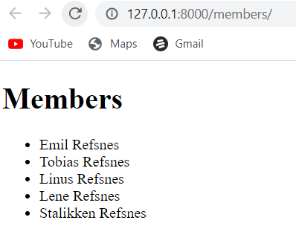

Django Add Link to Details

Details Template. The next step in our web page will be to add a Details page, where we can list more details about a specific member. Start by creating a new template called details.html:
my_tennis_club/members/templates/details.html:
<!DOCTYPE html>
<html>
<body>
<h1>{{ mymember.firstname }} {{ mymember.lastname }}</h1>
<p>Phone: {{ mymember.phone }}</p>
<p>Member since: {{ mymember.joined_date }}</p>
<p>Back to <a href="/members">Members</a></p>
</body>
</html>

Add Link in all-members Template The list in all_members.html should be clickable, and take you to the details page with the ID of the member you clicked on: my_tennis_club/members/templates/all_members.html:
<!DOCTYPE html>
<html>
<body>
<h1>Members</h1>
<ul>
{% for x in mymembers %}
<li><a href="details/{{ x.id }}">{{ x.firstname }} {{ x.lastname }}</a></li>
{% endfor %}
</ul>
</body>
</html>

Create new View. Then create a new view in the views.py file, that will deal with incoming requests to the /details/ url: my_tennis_club/members/views.py:
from django.http import HttpResponse
from django.template import loader
from .models import Member
def members(request):
mymembers = Member.objects.all().values()
template = loader.get_template('all_members.html')
context = {
'mymembers': mymembers,
}
return HttpResponse(template.render(context, request))
def details(request, id):
mymember = Member.objects.get(id=id)
template = loader.get_template('details.html')
context = {
'mymember': mymember,
}
return HttpResponse(template.render(context, request))

The details view does the following:
- Gets the id as an argument.
- Uses the id to locate the correct record in the Member table.
- loads the details.html template.
- Creates an object containing the member.
- Sends the object to the template.
- Outputs the HTML that is rendered by the template.

Add URLs. Now we need to make sure that the /details/ url points to the correct view, with id as a parameter. Open the urls.py file and add the details view to the urlpatterns list:
my_tennis_club/members/urls.py:
from django.urls import path
from . import views
urlpatterns = [
path('members/', views.members, name='members'),
path('members/details/<int:id>', views.details, name='details'),
]
If you have followed all the steps on your own computer, you can see the result in your own browser: 127.0.0.1:8000/members/.
If the server is down, you have to start it again with the runserver command:
py manage.py runserver

Django Add Master Template

The extends Tag. In the previous pages we created two templates, one for listing all members, and one for details about a member. The templates have a set of HTML code that are the same for both templates.
Django provides a way of making a "parent template" that you can include in all pages to for the stuff that are the same in all pages. Start by creating a template called master.html, with all the necessary HTML elements:

Master
my_tennis_club/members/templates/master.html:
<!DOCTYPE html>
<html>
<head>
<title>{% block title %}{% endblock %}</title>
</head>
<body>

{% block content %}
{% endblock %}
</body>
</html>
Do you see Django block Tag inside the <title> element, and the <body> element?
They are placeholders, telling Django to replace this block with content from other sources.

Modify Templates Now the two templates (all_members.html and details.html) can use this master.html template. This is done by including the master template with the {% extends %} tag, and inserting a title block and a content block:

Members
my_tennis_club/members/templates/all_members.html:
{% extends "master.html" %}
{% block title %}
My Tennis Club - List of all members
{% endblock %}
{% block content %}
<h1>Members</h1>
<ul>
{% for x in mymembers %}
<li><a href="details/{{ x.id }}">{{ x.firstname }} {{ x.lastname }}</a></li>
{% endfor %}
</ul>
{% endblock %}

Details. my_tennis_club/members/templates/details.html:
{% extends "master.html" %}
{% block title %}
Details about {{ mymember.firstname }} {{ mymember.lastname }}
{% endblock %}
{% block content %}
<h1>{{ mymember.firstname }} {{ mymember.lastname }}</h1>
<p>Phone {{ mymember.phone }}</p>
<p>Member since: {{ mymember.joined_date }}</p>
<p>Back to <a href="/members">Members</a></p>
{% endblock %}
If you have followed all the steps on your own computer, you can see the result in your own browser: 127.0.0.1:8000/members/.
If the server is down, you have to start it again with the runserver command:
py manage.py runserver
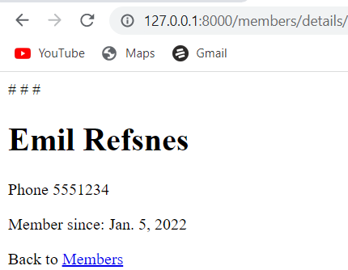
DJANGO Add main Index page

Main Index Page. Our project needs a main page. The main page will be the landing page when someone visits the root folder of the project. Now, you get an error when visiting the root folder of your project:
127.0.0.1:8000/.
Start by creating a template called main.html: Main
my_tennis_club/members/templates/main.html:
{% extends "master.html" %}
{% block title %}
My Tennis Club
{% endblock %}
{% block content %}
<h1>My Tennis Club</h1>
<h3>Members</h3>
<p>Check out all our <a href="members/">members</a></p>
{% endblock %}

Create new View. Then create a new view called main, that will deal with incoming requests to root of the project:
my_tennis_club/members/views.py:
from django.http import HttpResponse
from django.template import loader
from .models import Member
def members(request):
mymembers = Member.objects.all().values()
template = loader.get_template('all_members.html')
context = {
'mymembers': mymembers,
}
return HttpResponse(template.render(context, request))
def details(request, id):
mymember = Member.objects.get(id=id)
template = loader.get_template('details.html')
context = {
'mymember': mymember,
}
return HttpResponse(template.render(context, request))

def main(request):
template = loader.get_template('main.html')
return HttpResponse(template.render())
The main view does the following:
- loads the main.html template.
- Outputs the HTML that is rendered by the template.

Add URL. Now we need to make sure that the root url points to the correct view.
Open the urls.py file and add the main view to the urlpatterns list:
my_tennis_club/members/urls.py:
from django.urls import path
from . import views
urlpatterns = [
path('', views.main, name='main'),
path('members/', views.members, name='members'),
path('members/details/<int:id>', views.details, name='details'),
]

Add Link Back to Main. The members page is missing a link back to the main page, so let us add that in the all_members.html template, in the content block: Example
my_tennis_club/members/templates/all_members.html:
{% extends "master.html" %}
{% block title %}
My Tennis Club - List of all members
{% endblock %}
{% block content %}
<p><a href="/">HOME</a></p>
<h1>Members</h1>
<ul>
{% for x in mymembers %}
<li><a href="details/{{ x.id }}">{{ x.firstname }} {{ x.lastname }}</a></li>
{% endfor %}
</ul>
{% endblock %}
If you have followed all the steps on your own computer, you can see the result in your own browser: 127.0.0.1:8000/.
If the server is down, you have to start it again with the runserver command:
py manage.py runserver
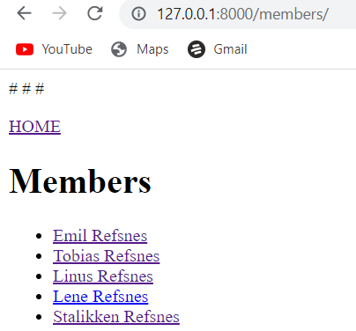

DJANGO 404 (page not found)

Page Not Found. If you try to access a page that does not exist (a 404 error), Django directs you to a built-in view that handles 404 errors. You will learn how to customize this 404 view later in this chapter, but first, just try to request a page that does not exist. In the browser window, type 127.0.0.1:8000/masfdfg/ in the address bar.
You will get one of two results:
1:
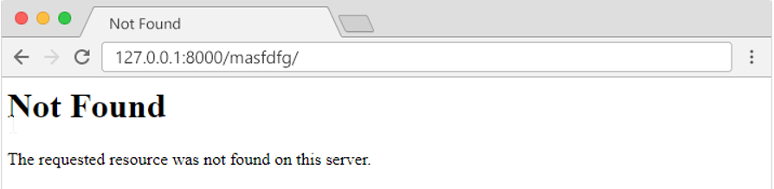
2:
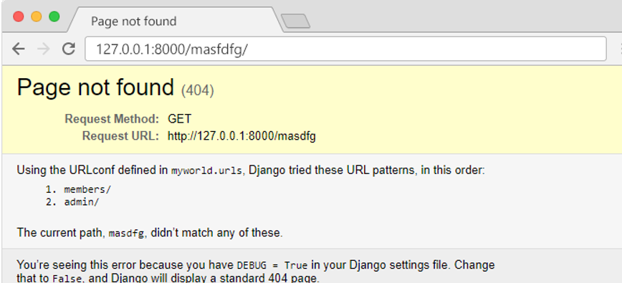
If you got the first result, you got directed to the built-in Django 404 template. If you got the second result, then DEBUG is set to True in your settings, and you must set it to False to get directed to the 404 template.
This is done in the settings.py file, which is located in the project folder, in our case the my_tennis_club folder, where you also have to specify the host name from where your project runs from:

Example. Set the debug property to False, and allow the project to run from your local host:
my_tennis_club/my_tennis_club/settings.py:
.
.
# SECURITY WARNING: don't run with debug turned on in production!
DEBUG = False

ALLOWED_HOSTS = ['*']
.
.
Important: When DEBUG = False, Django requires you to specify the hosts you will allow this Django project to run from. In production, this should be replaced with a proper domain name:
ALLOWED_HOSTS = ['yourdomain.com']
In the browser window, type 127.0.0.1:8000/masfdfg/ in the address bar, and you will get the built-in 404 template:
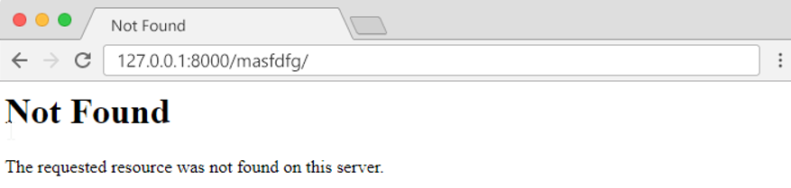

Customize the 404 Template. Django will look for a file named 404.html in the templates folder, and display it when there is a 404 error. If no such file exists, Django shows the "Not Found" that you saw in the example above.
To customize this message, all you have to do is to create a file in the templates folder and name it 404.html, and fill it with write whatever you want:
my_tennis_club/members/templates/404.html:
<!DOCTYPE html>
<html>
<title>Wrong address</title>
<body>
<h1>Ooops!</h1>
<h2>I cannot find the file you requested!</h2>
</body>
</html>
In the browser window, type 127.0.0.1:8000/masfdfg/ in the address bar, and you will get the customized 404 template:
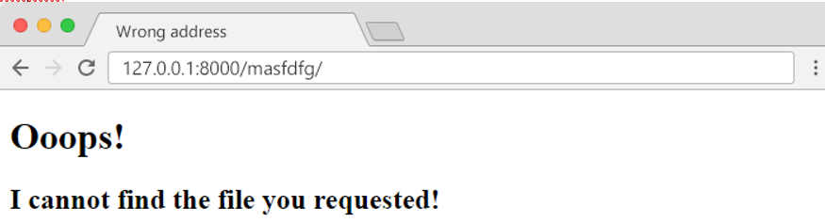
DJANGO Add Test views

Test View. When testing different aspects of Django, it can be a good idea to have somewhere to test code without destroying the main project.
This is optional off course, but if you like to follow all steps in this tutorial, you should add a test view that is exactly like the one we create below. Then you can follow the examples and try them out on your own computer.

Add View. Start by adding a view called "testing" in the views.py file:
my_tennis_club/members/views.py:
from django.http import HttpResponse
from django.template import loader
from .models import Member
def members(request):
mymembers = Member.objects.all().values()
template = loader.get_template('all_members.html')
context = {
'mymembers': mymembers,
}
return HttpResponse(template.render(context, request))
def details(request, id):
mymember = Member.objects.get(id=id)
template = loader.get_template('details.html')
context = {
'mymember': mymember,
}
return HttpResponse(template.render(context, request))
def main(request):
template = loader.get_template('main.html')
return HttpResponse(template.render())

def testing(request):
template = loader.get_template('template.html')
context = {
'fruits': ['Apple', 'Banana', 'Cherry'],
}
return HttpResponse(template.render(context, request))

URLs
We have to make sure that incoming urls to /testing/ will be redirected to the testing view.
This is done in the urls.py file in the members folder:
my_tennis_club/members/urls.py:
from django.urls import path
from . import views
urlpatterns = [
path('', views.main, name='main'),
path('members/', views.members, name='members'),
path('members/details/<int:id>', views.details, name='details'),
path('testing/', views.testing, name='testing'),
]

Test Template. We also need a template where we can play around with HTML and Django code. You might noticed that there was a reference to a template in the testing view? Create a template called "template.html" in the templates folder:
my_tennis_club
manage.py
my_tennis_club/
members/
templates/
404.html
all_members.html
details.html0
main.html
master.html
myfirst.html
template.html
Open the template.html file and insert the following:
my_tennis_club/members/templates/template.html:
<!DOCTYPE html>
<html>
<body>
{% for x in fruits %}
<h1>{{ x }}</h1>
{% endfor %}
<p>In views.py you can see what the fruits variable looks like.</p>
</body>
</html>
If the server is not running, navigate to the /my_tennis_club folder and execute this command in the command prompt:
py manage.py runserver
In the browser window, type 127.0.0.1:8000/testing/ in the address bar. The result should be like this:
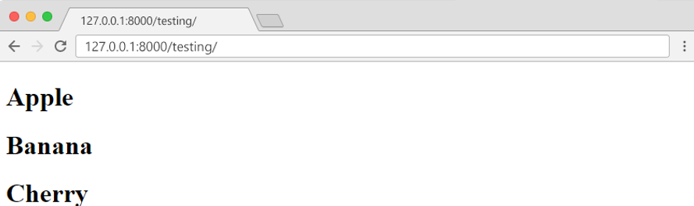

Django Admin
Django Admin is a really great tool in Django, it is actually a CRUD* user interface of all your models!
*CRUD stands for Create Read Update Delete. It is free and comes ready-to-use with Django:
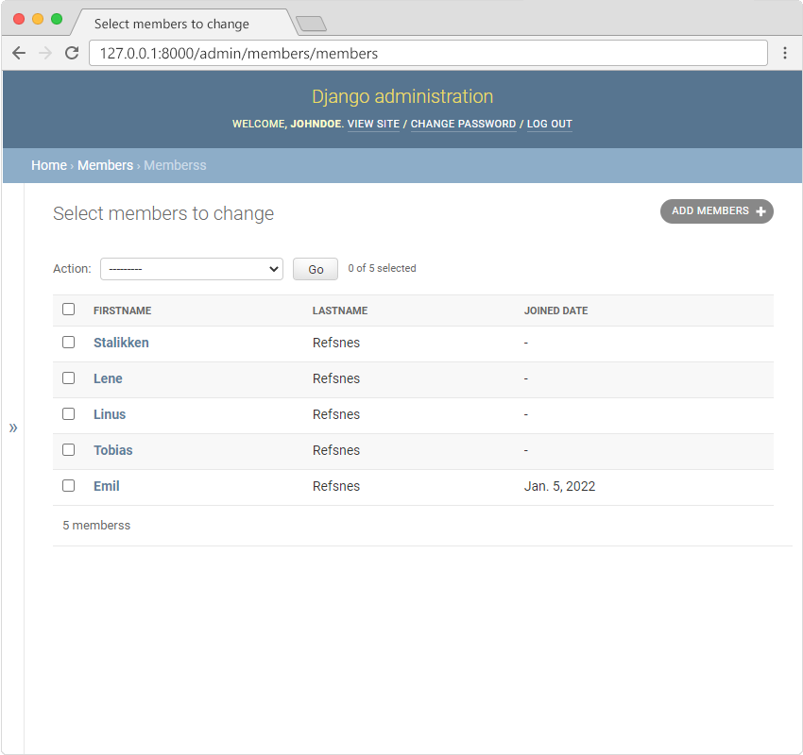

Getting Started To enter the admin user interface, start the server by navigating to the /myworld folder and execute this command: Ojo en my_tennis_Club no en myworld no existe allá manage.py
py manage.py runserver
In the browser window, type 127.0.0.1:8000/admin/ in the address bar.
The result should look like this:
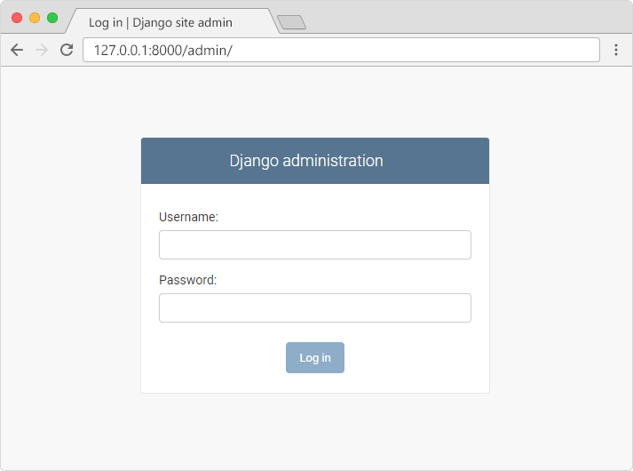
The reason why this URL goes to the Django admin log in page can be found in the urls.py file of your project:
my_tennis_club/my_tennis_club/urls.py:
from django.contrib import admin
from django.urls import include, path

urlpatterns = [
path('', include('members.urls')),
path('admin/', admin.site.urls),
]

The urlpatterns[] list takes requests going to admin/ and sends them to admin.site.urls, which is part of a built-in application that comes with Django, and contains a lot of functionality and user interfaces, one of them being the log-in user interface.

Create User
To be able to log into the admin application, we need to create a user. This is done by typing this command in the command view:
py manage.py createsuperuser
Which will give this prompt:
Username:
Here you must enter: username, e-mail address, (you can just pick a fake e-mail address), and password:
Username: johndoe
Email address: johndoe@dummymail.com
Password:
Password (again):
This password is too short. It must contain at least 8 characters.
This password is too common.
This password is entirely numeric.
Bypass password validation and create user anyway? [y/N]:
My password did not meet the criteria, but this is a test environment, and I choose to create user anyway, by enter y:
Bypass password validation and create user anyway? [y/N]: y
If you press [Enter], you should have successfully created a user:
Superuser created successfully.
Now start the server again:
py manage.py runserver
In the browser window, type 127.0.0.1:8000/admin/ in the address bar.
And fill in the form with the correct username and password:

Include Member in the Admin Interface
To include the Member model in the admin interface, we have to tell Django that this model should be visible in the admin interface. This is done in a file called admin.py, and is located in your app's folder, which in our case is the members folder. Open it, and it should look like this:
my_tennis_club/members/admin.py:
from django.contrib import admin

# Register your models here.
Insert a couple of lines here to make the Member model visible in the admin page:
my_tennis_club/members/admin.py:
from django.contrib import admin
from .models import Member

# Register your models here.
admin.site.register(Member)
Now go back to the browser and you should get this result:
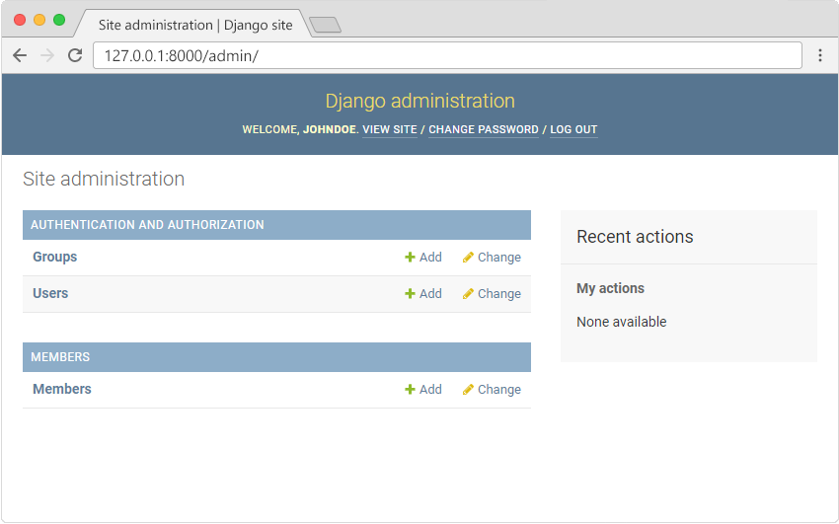
Click Members and see the five records we inserted earlier in this tutorial:
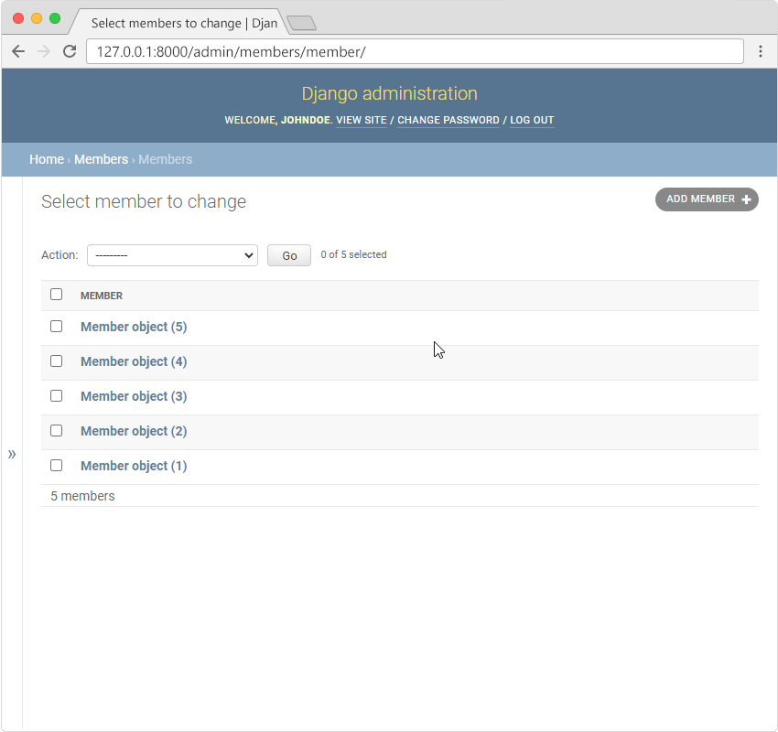

Change Display
In the list in the screenshot above, we see "Member object (1)", "Member object (2)" etc. which might not be the data you wanted to be displayed in the list. It would be better to display "firstname" and "lastname" instead.
This can easily be done by changing some settings in the models.py and/or the admin.py files. You will learn more about this in the next chapter.

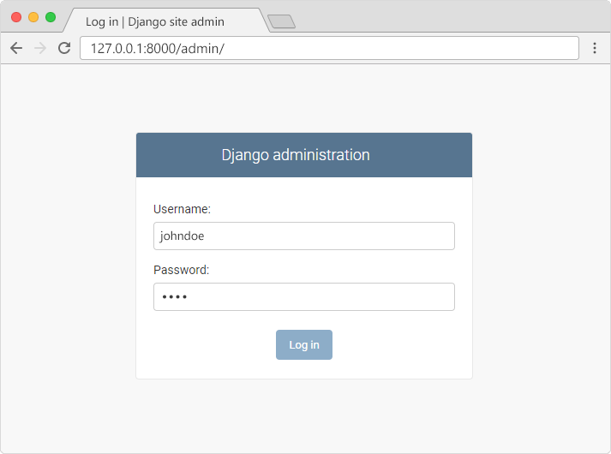
Which should result in this user interface:
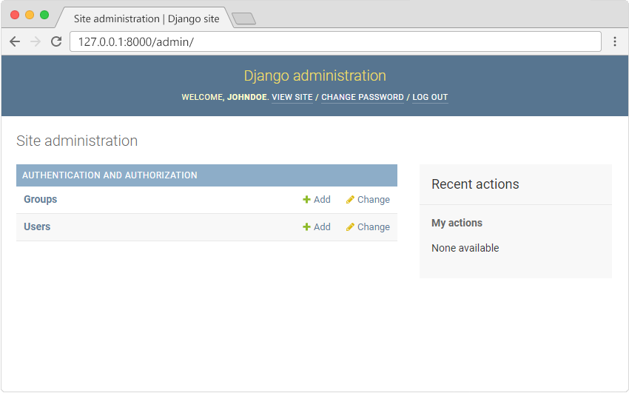
Here you can create, read, update, and delete groups and users, but where is the Members model?

Missing Model
The Members model is missing, as it should be, you have to tell Django which models that should be visible in the admin interface. You will learn how to include the Members model in the next chapter.

Make the List Display More Reader-Friendly
When you display a Model as a list, Django displays each record as the string representation of the record object, which in our case is "Member object (1)", "Member object(2)" etc.:
To change this to a more reader-friendly format, we have two choices:
- Change the string representation function, __str__() of the Member Model
- Set the list_details property of the Member Model

Change the String Representation Function
To change the string representation, we have to define the __str__() function of the Member Model in models.py, like this:
my_tennis_club/members/models.py:
from django.db import models
class Member(models.Model):
firstname = models.CharField(max_length=255)
lastname = models.CharField(max_length=255)
phone = models.IntegerField(null=True)
joined_date = models.DateField(null=True)
def __str__(self):
return f"{self.firstname} {self.lastname}"
Which gives us this result:
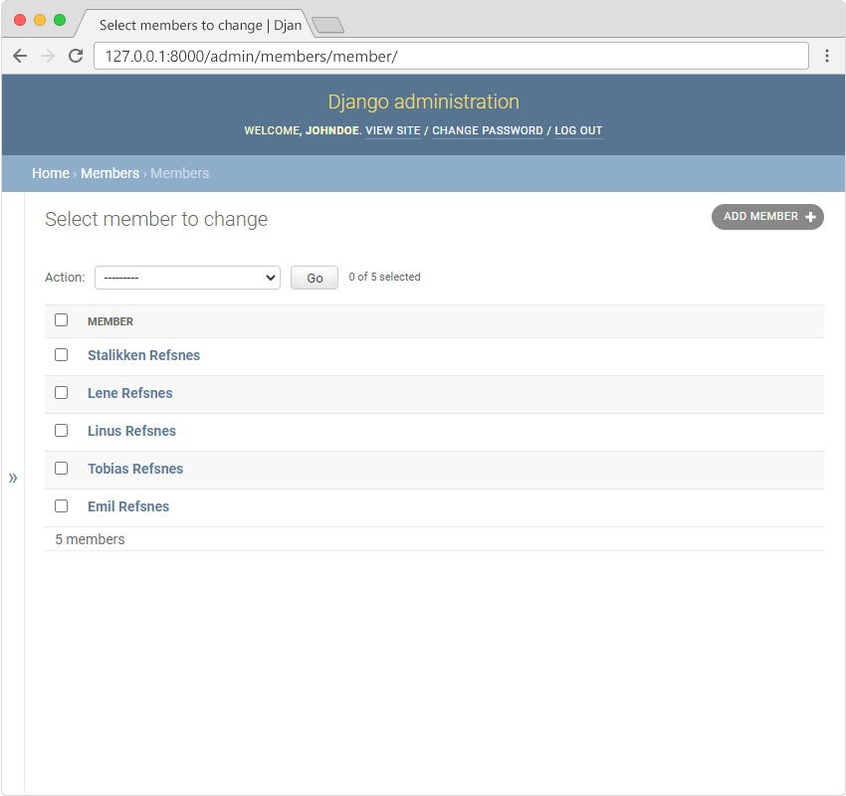
Defining our own __str__() function is not a Django feature, it is how to change the string representation of objects in Python. Read more about Python objects in our Python object tutorial.

Set list_display
We can control the fields to display by specifying them in in a list_display property in the admin.py file.
First create a MemberAdmin() class and specify the list_display tuple, like this:
my_tennis_club/members/admin.py:
from django.contrib import admin
from .models import Member
# Register your models here.
class MemberAdmin(admin.ModelAdmin):
list_display = ("firstname", "lastname", "joined_date",)
admin.site.register(Member, MemberAdmin)

Remember to add the MemberAdmin as an argumet in the admin.site.register(Member, MemberAdmin).
Now go back to the browser and you should get this result:
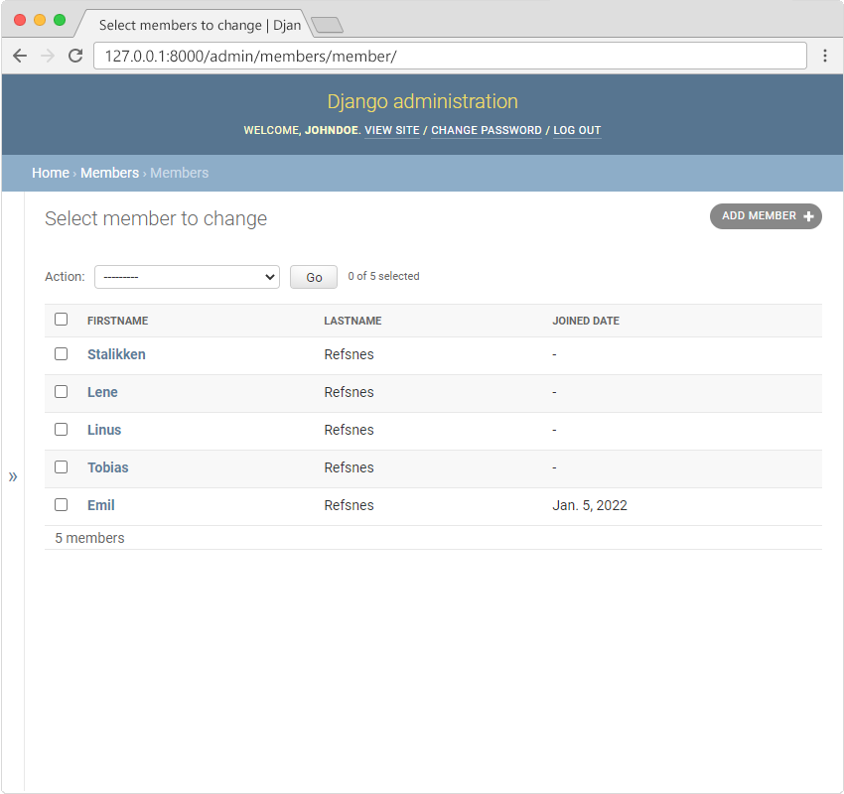

Update Members
Now we are able to create, update, and delete members in our database, and we start by giving them all a date for when they became members. Click the first member, Stalikken, to open the record for editing, and give him a joined_date:
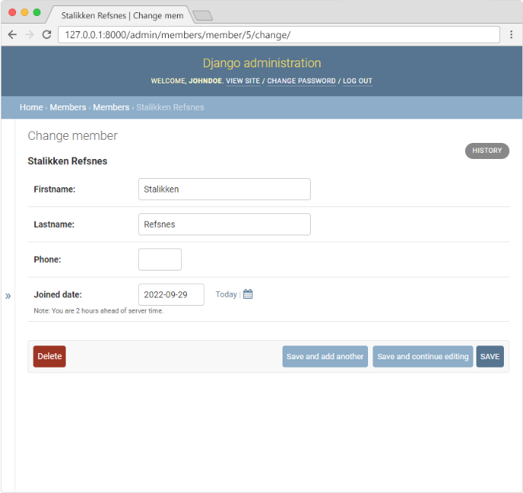
While we are in here, let us give him a phone number as well:
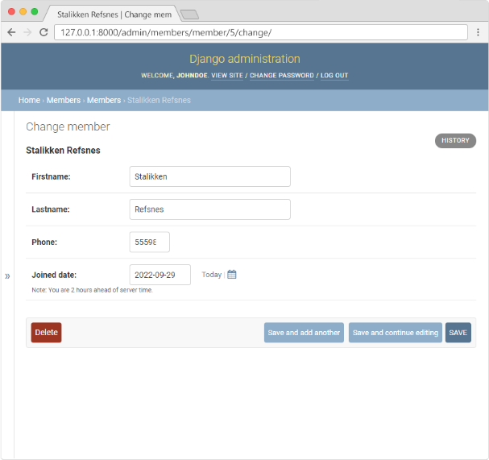
Click "SAVE" and go back to the list of all members:
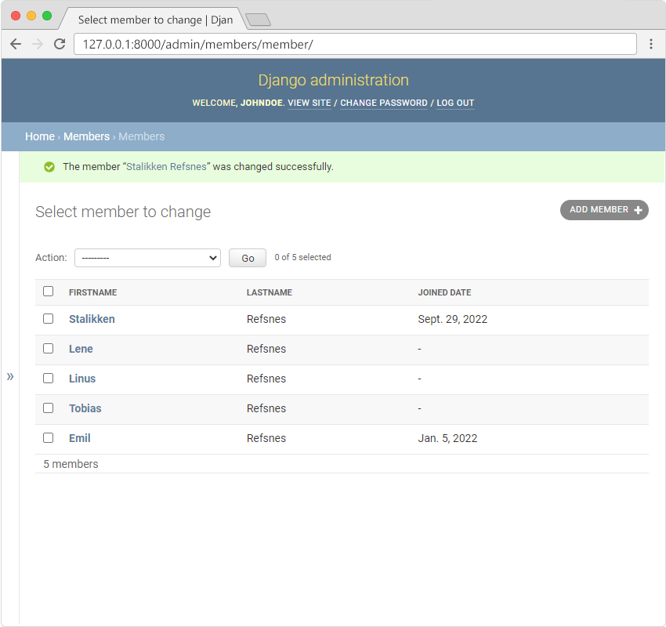
Repeat these steps and give all members a date and a phone number, and end up with a list like this:
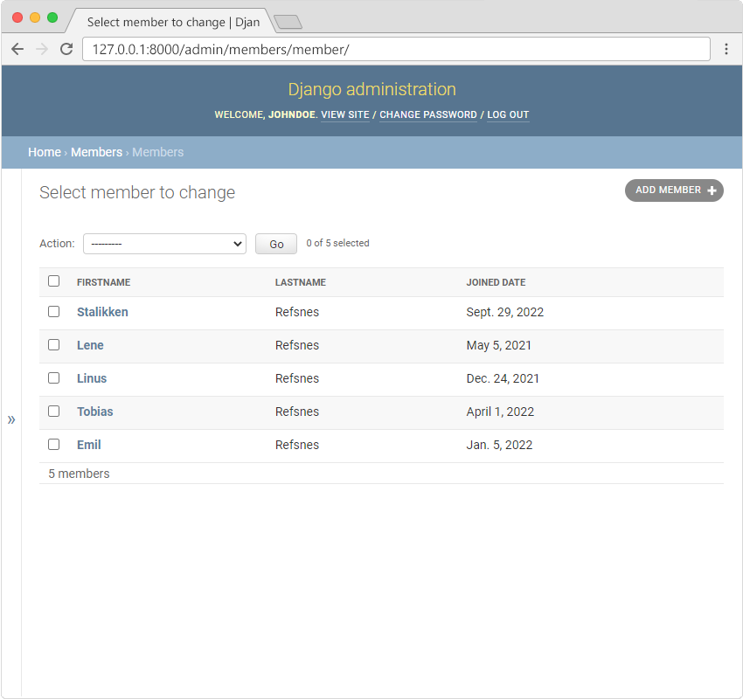

Add Members To add a new member, click on the "ADD MEMBERS" button in the top right corner:
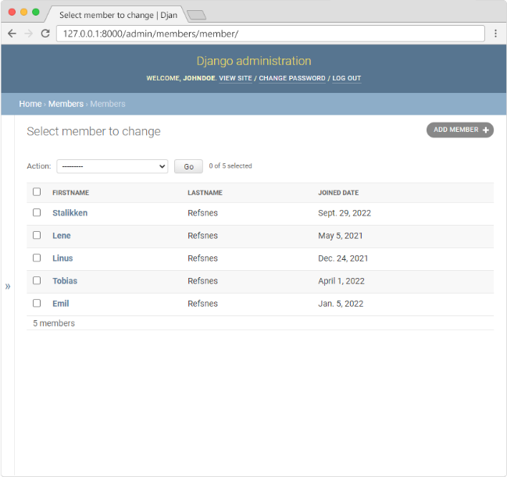
You will get an empty form where you can fill in the members fields:
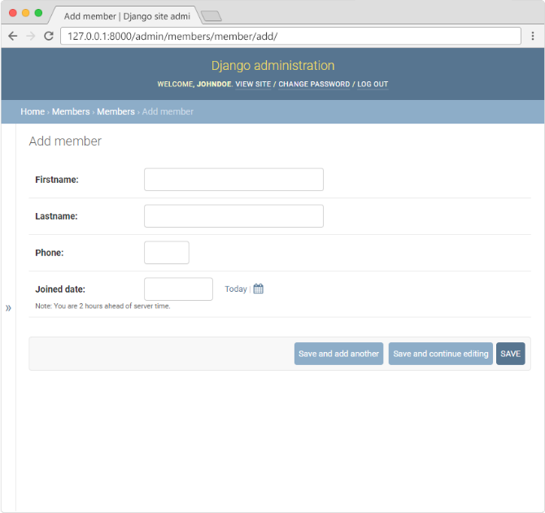
Fill in the fields and click "SAVE":
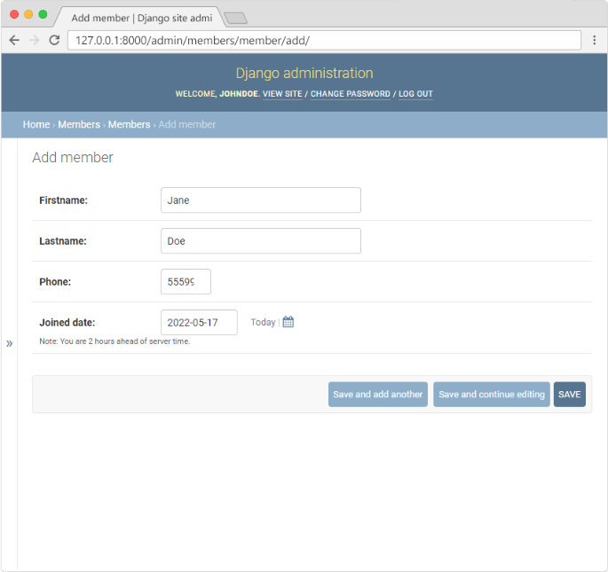
Now the Members Model have 6 members:
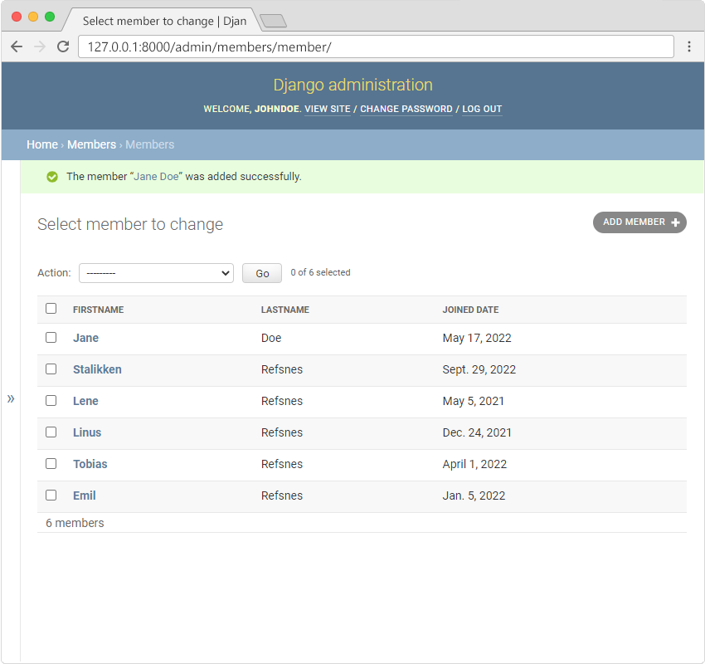:

Delete Members. To delete a new member, you can either select a member and choose the action "Delete selected members" like this:
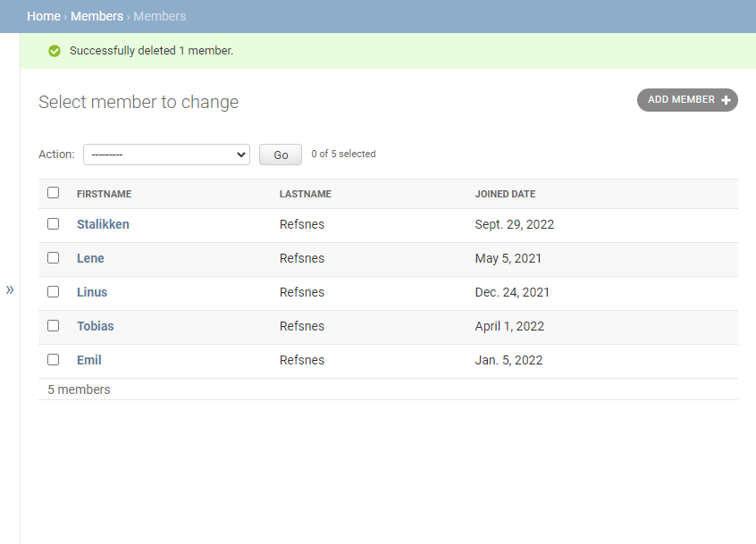
Or you can open a member for editing, and click the red DELETE button at the bottom, like this: Run Demo

My first app with django Python part1 (another versión)
$ python -m django –version
$ django-admin startproject mysite
Let’s look at what startproject created:
mysite/
manage.py
mysite/
__init__.py
settings.py
urls.py
asgi.py
wsgi.py

